Quality and Environmental Policy

Vision
SWMAS’ vision is to be recognised as the leading business support provider for manufacturing support, using our expertise to offer dynamic, inspirational business improvement to help small and medium manufacturers realise their growth ambitions.

Mission
Our mission is to inspire and support the growth and success of our clients by using our expertise, local area knowledge, and unique connections to provide insight, create solutions, leverage resources and deliver meaningful business improvement.

To help ensure we achieve our Mission and realise our Vision we will;

- To help bring a voice to the SME manufacturing sector.
- Deliver products and services that support ambitious businesses to improve their performance, develop skills and reach their growth potential whilst helping them to reduce their impact on the environment.
- Work continually to improve everything we do so that our services meet or exceed the expectations of our clients and other interested stakeholders, striving for world class levels of customer satisfaction.
- Create a working environment where every employee is fully committed to delivering the highest standards of service by ensuring they are kept informed and have the skills and confidence to perform their tasks, safely and competently.
- Conduct our business in a manner that complies with ISO 9001, ISO 14001 applicable health, safety and environmental legislation and contractual and other requirements whilst at the same time protecting the environment and preventing pollution.
- Set, communicate and monitor objectives intended to improve quality and environmental performance.
- Be open about our environmental activities and, where appropriate, provide information to stakeholders regarding quality and environmental matters.
- Achieve Net Zero by 2040 and continue to focus on lowering the overall environmental impact in the services we deliver.
- Identify and manage risks associated with our business activities, client satisfaction and the environment and ensure these risks are considered whenever there are changes to business activities, client and regulatory requirements.
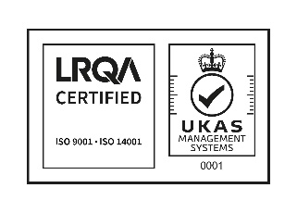
- Review this policy on an annual basis to ensure it continues to complement our vision and mission.

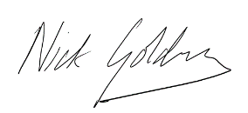
Nick Golding
Director - March 2024

